**Reclaimed Wood Floating Wall Shelf**

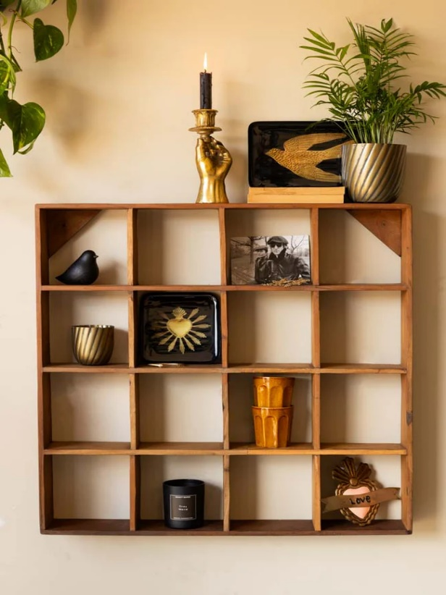A reclaimed wood floating wall shelf brings rustic charm and eco-friendly elegance to your space. Made from repurposed wood, each shelf showcases unique imperfections, grain patterns, and weathered textures that tell a story of its past. Perfect for displaying plants, books, or decorative accents, its minimalist, no-bracket design creates a clean, floating effect that enhances the natural beauty of the wood. Ideal for farmhouse, industrial, or bohemian interiors, this shelf combines sustainability with timeless style.

.